JPET STORE APPLICATION

Performance Test Plan

Prepared By: Jayanth Reddy
Date: 23-05-2024
Version: 1.0

Document Revision History

Version | Date | Updated by | Description of Change(s)
1.0 Draft | MAY 23, 2024 | Jayanth Reddy | First Draft

Signature Page
APPROVAL:

Decision:

Reject: Y / N | Proceed: Y / N | Priority: H , M , L

Reasons / Remarks:

Created by:
Project Team |  | Date
Jayanth Reddy |  | 23/05/2024
Table of Contents

1. Overview………………………………………………………........... 5
2. Objective………………………………………………………………. 5
3. Assumptions…………………………………………………………… 6
4. Scope………………………………………………………………….. 6
5. Items Out of Scope……………………………………………………. 6
6. Schedule……………………………………..…………………….…. . 7
7. Approach………………………………………………………………. 8

8. Application Architecture……………………………………………….. 8
9. Performance Tool Architecture……………………………………… 9
10. Pre-Requisites…………………………………………………………. 10
11. Test Data……………………………………………………………….. 10
12. Monitoring……………………………………………………………… 10
13. Performance Monitors – All Servers………………………………… 10
14. Oracle – Database Servers ………………………………………… 11
15. LoadRunner Monitors (GUI) ………………………………………...… 11
16. Entry / Exit Criteria…………………………………………………….. 11
17. Deliverables / Documents……………………………………………... 11
18. Roles & Responsibilities………………………………………………. 12
19. Risks & mitigations……………………………………………………. 12
19.1. Risks……………………………………………………………. 12

Overview

This document will describe the test scope, objective, approach, schedule and other artifacts related to the evaluating the performance of JPET STORE Application.

Performance Test plan defines the detailed test approach, execution procedure, objectives, roles and responsibilities and associated activities supporting the test.

Objective

To verify the non-functional requirements.

Performance Testing will enable JPET STORE Application to determine the overall readiness of selected Business flow to achieve the performance levels necessary to meet certain non-functional business objectives requirements.
The following goals and objectives are defined for the integrated performance test:

- Compare the results and benchmark some cases.

- To establish performance benchmarks of system throughput and/ or volume and application response time.

- Identify bottlenecks in the system hardware & software and application.

- Identify inputs to performance tuning of these systems prior to and during the early stages of deployment.

- Replicate stress on the system.

- To minimize the number of unknown performance-related behaviors of the systems related to the application going into Production.

Assumptions

It is assumed that:

- The performance test team will create Performance Test Case and Conditions document
- Business team and users will provide functional flow and process for each of the JPET STORE application components.
- The Database Team will provide performance test data and work with the Performance Test Team to monitor and capture performance metrics.
- The data size for the test environment is set up with production-like volumes.
- Limited changes to Scope will take place after the Sign-off of the Performance Test Case and Conditions document.
- Limited Access to environments and systems required by the Performance test team.
- JPET STORE is responsible for ensuring that the solution meets the company internal requirements.
- JPET STORE will assist in the definition of test cases as well as reviewing execution results.
- JPET STORE will provide necessary software licenses.

Scope

Verifying the non-functional requirements for JPET STORE application.

Items Out of Scope

- Functional validation or system testing
- Third party interfaces / applications such as MDM/R and other supporting systems

Schedule

 | Type of test | Planned Start date | Planned End date
1 | POC | 23May2024 | 23May2024
2 | NFR | 23May2024 | 23May2024
3 | Test Plan | 23May2024 | 23May2024
4 | Work Load  Model | 23May2024 | 23May2024
5 | Scripting | 24May2024 | 24May2024
6 | Scenario Preparation | 24May2024 | 24May2024
7 | Load test | 25May2024 | 25May2024

Approach

The focus of performance testing is to simulate transactions & load, capture system response times and behavior under load, and get a reasonable picture of system stability and scalability. As part of this release we will conduct Load, stress and Endurance tests.

Application Architecture:

:

Performance Tool Architecture:

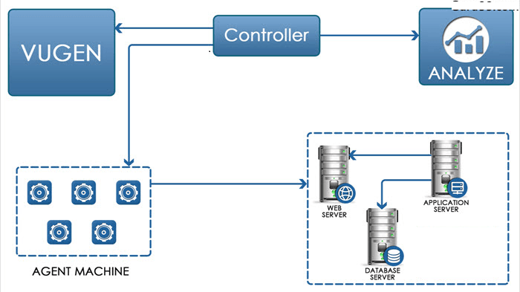

Performance Test Process Flow Schematic

Pre-Requisites

The performance testing team will use the following inputs before designing and executing the test scenarios in conjunction with JPET STORE Application technical team for both integrated performance testing and HTTP/HTML application performance testing:

- Historical data (from current production application)

- Understanding functional and process flow of application.

- Design, build, and execute performance test cases for the integrated performance test scenarios

- Stable Application

- Transaction response time for each scenario during Peak and Off Peak load.

- Non-Functional requirements will be used to determine the targeted or expected performance test volume information

- Target volume of data for each of the system component with expected run time

Test Data

Test Data will be provided by Application or DB Team.

Monitoring

The environment will be monitored during the performance testing the JPET STORE underlined System components.
.

Performance Monitors – All Servers
For GUI based performance testing such as batch processes, the following performance monitors will be setup to capture and log the following system / hardware level criteria:
  - CPU utilization
  - Disc utilization
  - Memory utilization

Oracle – Database Servers

Oracle performance tables will be queried, using STATSPACK to retrieve and log the following statistics:
  - Buffer cache hit ratios
  - Memory used / memory available
  - I/O In/Out
  - Index utilization
  - Table Space utilization

LoadRunner Monitors
LoadRunner monitoring tools will be used to track system utilization during performance testing of HTTP/HTML web base JPET STORE Application.
  - Hits per Second
  - Throughput
  - Transactions per second
  - Average Transaction Response Time (key indicator)

Entry / Exit Criteria

  - Build should be stable, functionality should be satisfied, NFR should be prepared, Historical data should be loaded.
  - Whenever Derived stats are meeting Expected Stats Consided.

Deliverables / Documents

Phase | Items
Initiation / Planning | Performance Test Plan
Test Preparation | Individual performance Test Case and Conditions document
Test Preparation | LoadRunner performance test scripts
Test Preparation | Load Runner performance test scenarios
Test Execution | Test Execution Summary Report
Test Execution | Individual performance Test Case and Conditions with detail references to supporting logs, output files, screenshots etc.
Test Execution | Defect summary updates
Test Completion | Consolidated final Test Completion Summary Report

Roles & Responsibilities
Sr. No | Designation | Name | Responsibilities
1 | Team Member | Jayanth Reddy | Performance Test Life Cycle

Risks & mitigations:
Performance testing could be severely impacted, resulting in incomplete or inadequate testing of the software, or adversely affecting the release date, by the following risks and dependencies:

Risks
The following are ongoing risks presented to Performance Testing that may impact the Schedule and/or Deliverables:

Risks | Mitigation Strategy
1. Application may crash while running load test | 1. Process has to be created to restore services by engaging system admin people
2. Non re-usable test data is present | 2. Creating the DB flash back point & restoration by engaging DB Admin
3. Test Data is present in Various Location | 3. Conduct test in various Time Zone

